Date functions:

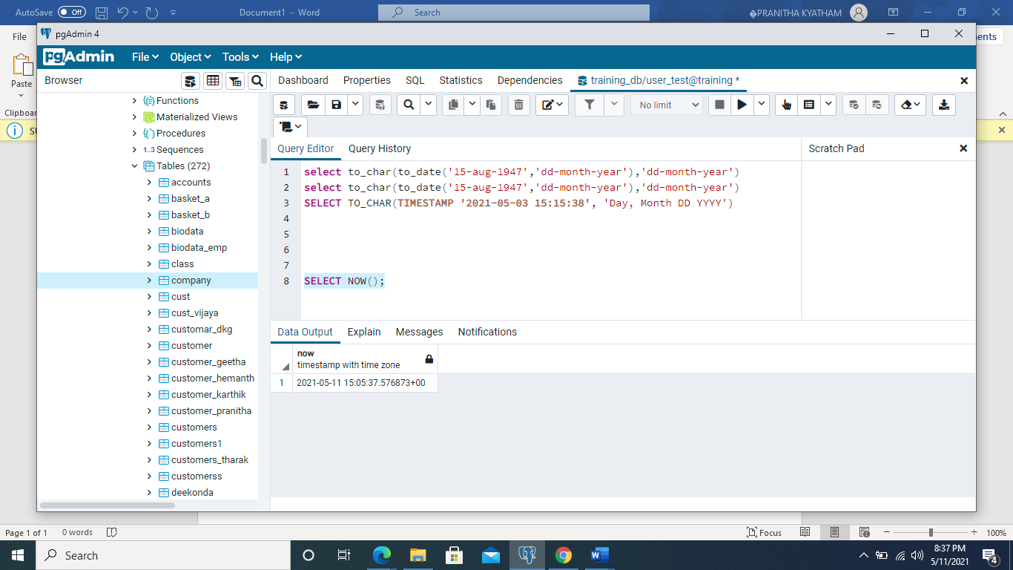

SELECT NOW();

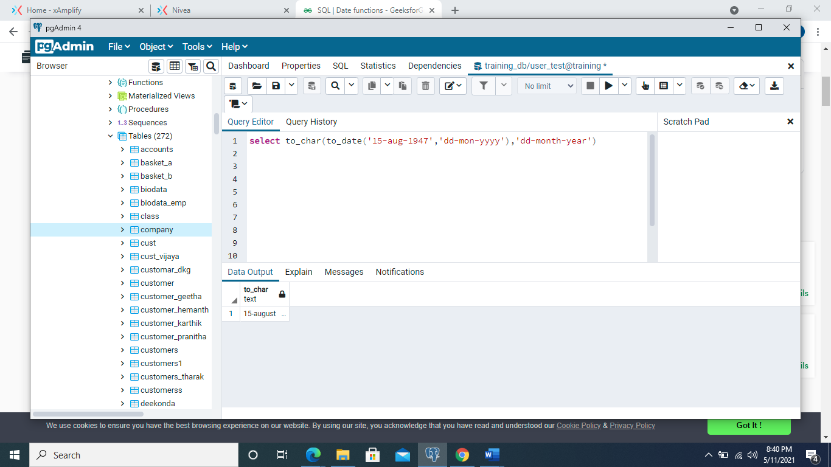

select to_char(to_date('15-aug-1947','dd-mon-yyyy'),'dd-month-year')

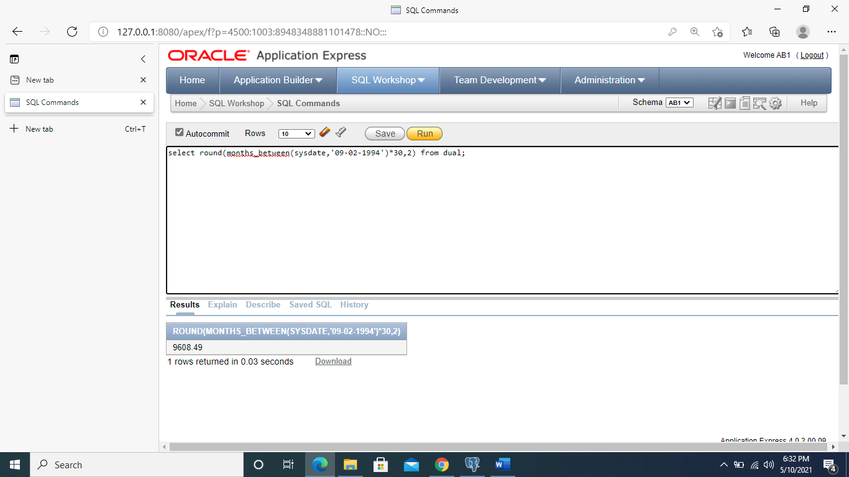

select round(months_between(sysdate,'09-02-1994')*30,2) from dual;

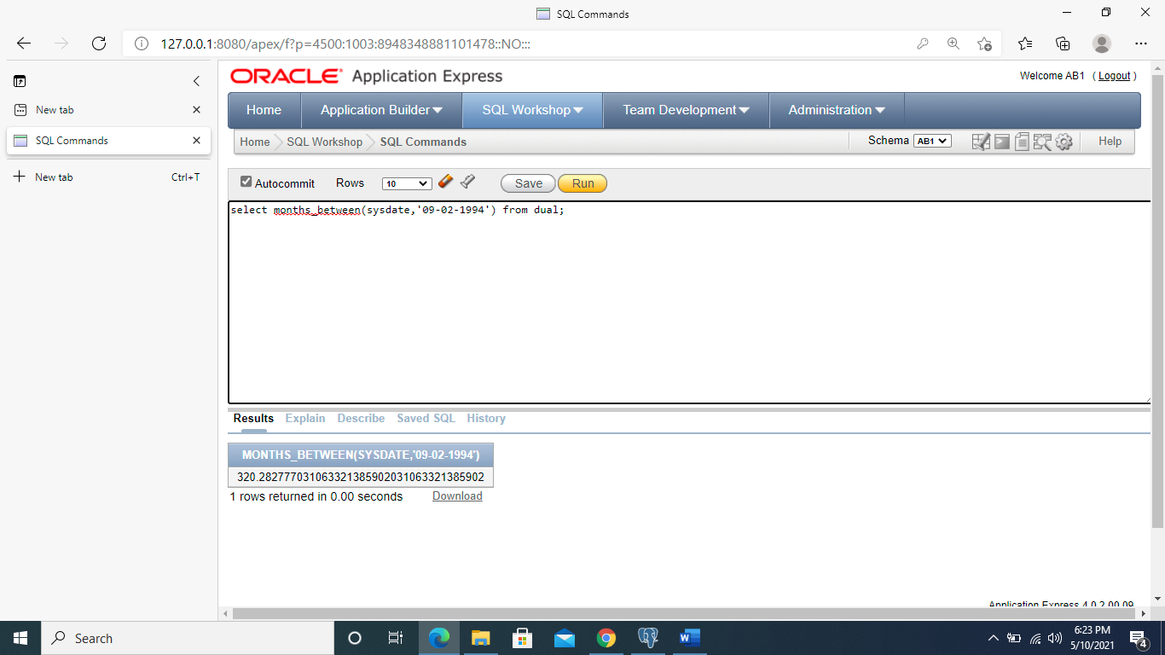

select months_between(sysdate,'09-02-1994') from dual;

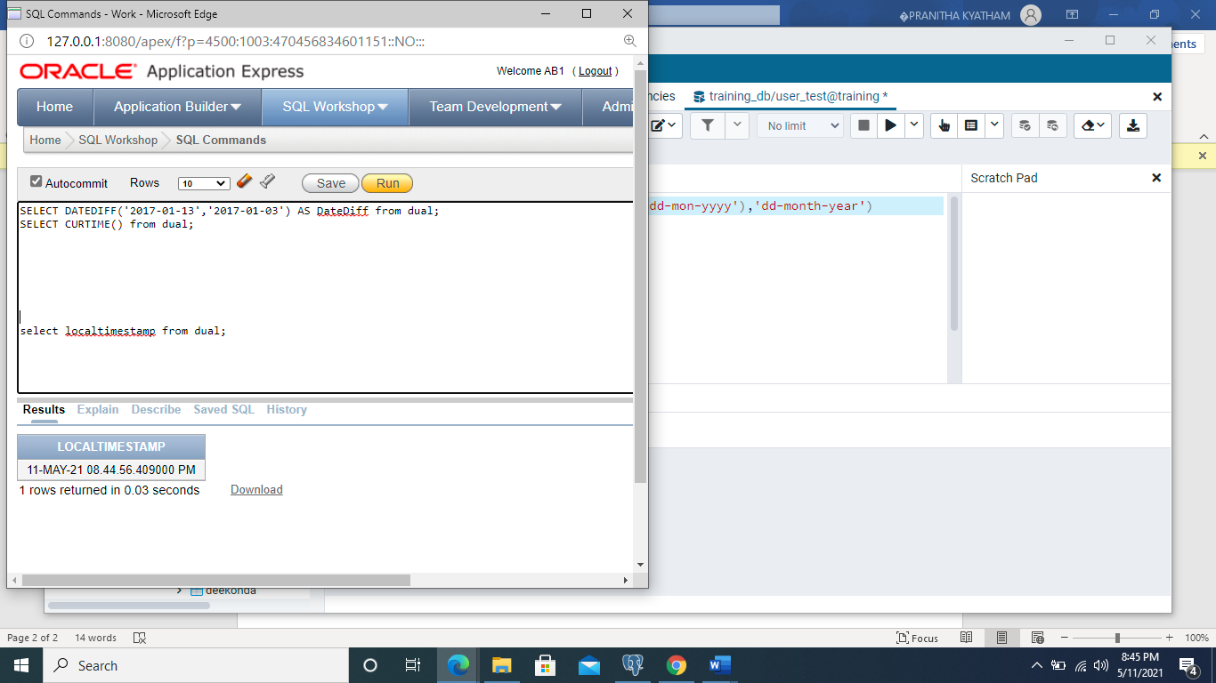

select localtimestamp from dual;